PI profile

Robert Beagrie
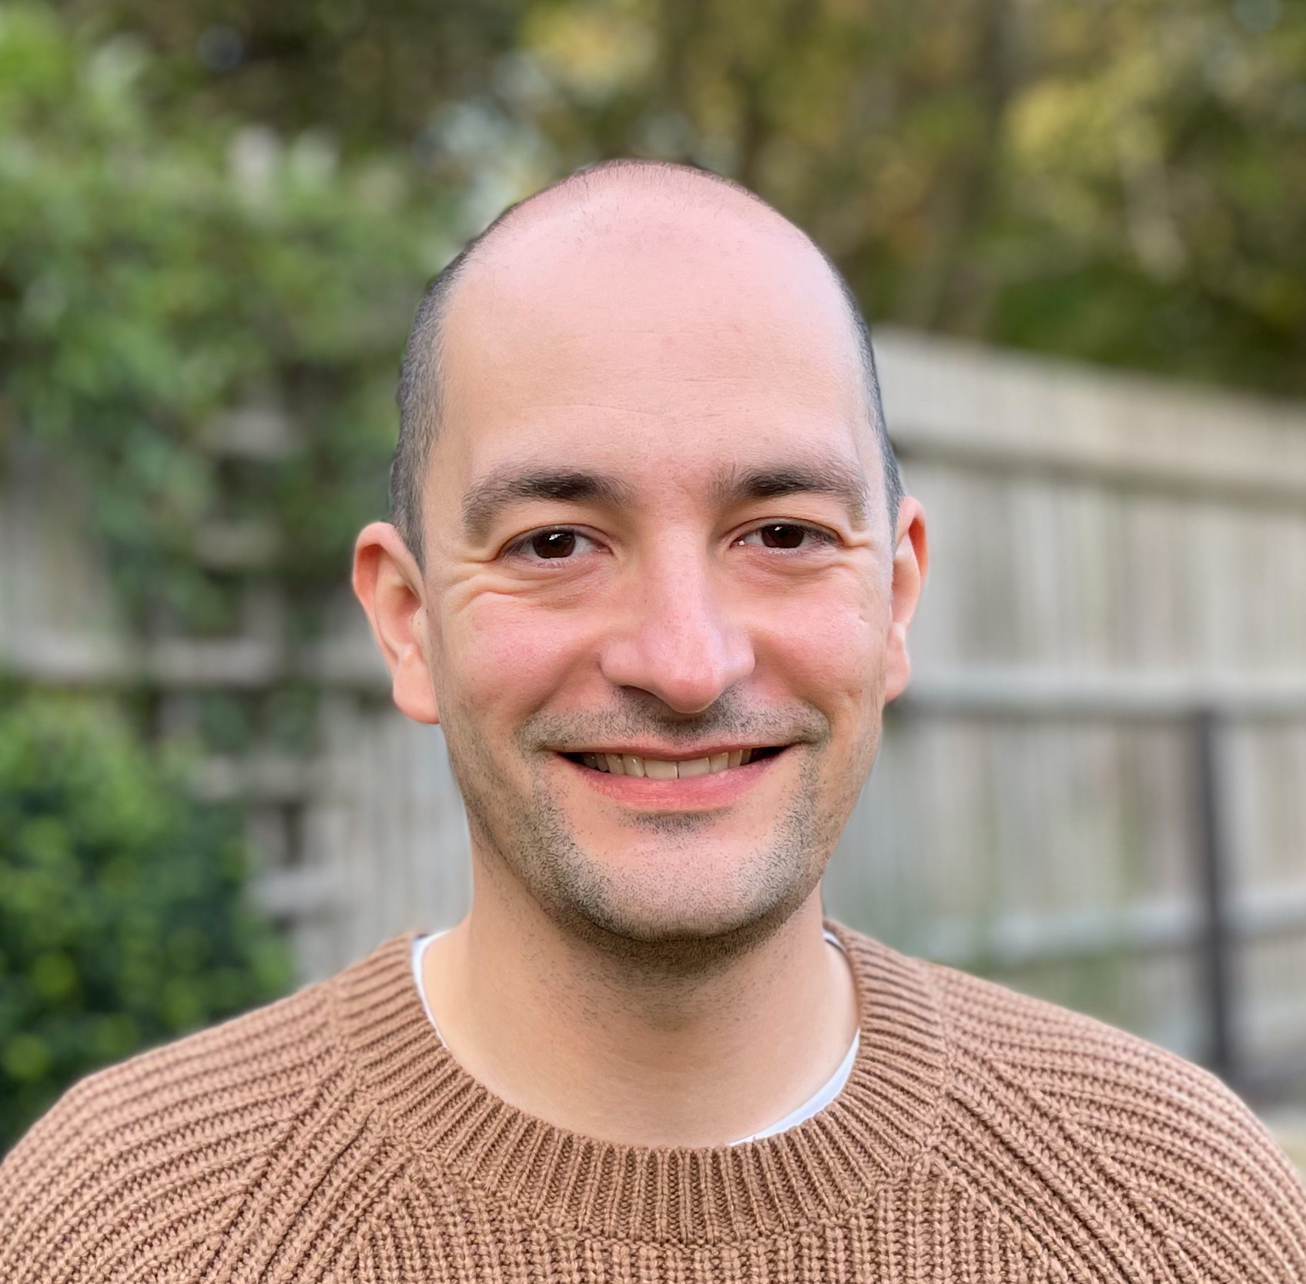 | Dr. Robert A. Beagrie  Titles: Group Leader and Sir Henry Dale Fellow  Location: Wellcome Centre for Human Genetics  Department: Nuffield Department of Medicine  Group: Chromatin and Disease  Webpage: https://www.beagrielab.com  Email: robert.beagrie@well.ox.ac.uk

GMS themes:
- Genomic and –omic technologies
- Functional genomics
- Genomic analysis (bioinformatics and statistical genetics)

Research Overview
Chromatin is highly organised in the nucleus. The correct distribution of histone marks and 3D folding of chromatin both contribute to normal gene expression and the maintenance of cell state. When these processes are disrupted, they can cause or contribute to human disease. Despite the universal nature of chromatin-based gene regulation, the consequences of chromatin disruption frequently impact the heart and the brain more than other tissues. My group’s aim is to understand the molecular basis of this tissue-specificity.
We use single-cell RNA-seq and spatial transcriptomics to identify affected cell types and dysregulated genes in models of chromatin disruption. We assess how chromatin organisation is affected by using ChIP-seq, CUT&RUN and ATAC-seq to identify differences in the distribution of histone variants, histone modifications or nucleosome-free regions. We also use Genome Architecture Mapping (GAM) to measure chromatin folding. We develop and apply computational analyses to identify common features of genes that are particularly sensitive to chromatin disruption.
Project areas: Chromatin, rare genetic disorders, brain development, heart development

Specific project proposals:

DPhil projects will be tailored to a candidate’s interests – if you’re interested please contact Rob to discuss. Available rotation projects are outlined below.

These pages were reviewed/updated: 29th September 2022

Project proposal

Title: Tissue-specific regulation of chromatin proteins in neural development
Supervisors: Dr. Robert Beagrie
Wet/dry lab mix (approx): 20% wet lab, 80% dry lab

Description:
Mutations chromatin organising genes cause a group of human syndromes called “chromatinopathies”. Loss of function mutations in these chromatin genes are frequently associated with some degree of impaired neural development. Some of these same genes are also more highly expressed in the brain than they are in other organs. These kinds of tissue-specific gene expression patterns are usually driven by regulatory DNA regions called enhancers. Common genetic variants that are associated with small changes in susceptibility to human disease can affect enhancers. Rare loss of function variants in the genes driven by these enhancers are often associated with a much higher risk of similar diseases. We therefore hypothesise that common human sequence variants affecting neural enhancers of chromatin genes might contribute to common neurological diseases (e.g. mental health issues)
The aim of this rotation project would be to identify potential neural enhancers driving brain-specific upregulation of chromatin genes in normal development. This would be done by exploring published datasets of open chromatin regions (bulk and single-cell ATAC-seq), histone modifications (ChIP-seq, single-cell CUT&TAG) and gene expression (bulk and single-cell RNA-seq) for various neural lineages. If we can identify possible enhancers, we would then ask whether any of these regions contain known sequence variants linked to common human disease (e.g. variants identified in Genome Wide Association Studies for mental health conditions).
There would also be the opportunity to validate brain specific expression patterns of the genes in question if the student particularly wanted to gain some wet-lab experience as part of this project.

Training Opportunities:
Students would be trained in analysis and mining of ATAC-seq, ChIP-seq, CUT&TAG, single-cell RNA-seq and Hi-C datasets. Computational analyses and training can be conducted in either R or Python according to the student’s preference. The student could also learn RNA extraction, qPCR and immunofluorescence as wet-lab techniques.

Background reading / references:

- Valencia AM and Pașca SP (2022). Chromatin Dynamics in Human Brain Development and Disease. Trends in Cell Biology. Available at: https://doi.org/10.1016/j.tcb.2021.09.001
- Ummi C and van Bokhoven H (2020). The Phenomenal Epigenome in Neurodevelopmental Disorders. Human Molecular Genetics. Available at: https://doi.org/10.1093/hmg/ddaa175
- Ziffra RS et al. (2021). Single-Cell Epigenomics Reveals Mechanisms of Human Cortical Development. Nature. Available at: https://doi.org/10.1038/s41586-021-03209-8

Project proposal

Title: Molecular basis of congenital heart defects in Cornelia de Lange Syndrome
Supervisors: Dr. Robert Beagrie
Wet/dry lab mix (approx): 50% wet lab, 50% dry lab

Description:
DNA loops allow enhancers to contact and activate their target genes in the 3D space of the nucleus. These loops are formed and stabilised by CTCF (a zinc-finger transcription factor) and cohesin (a ring-shaped multi-protein complex). Mutations in components of the cohesin complex cause a rare genetic disease called Cornelia de Lange Syndrome (CdLS) which affects between 1 in 10,000 and 1 in 50,000 individuals. Around 30% of CdLS patients are born with congenital heart defects. This project aims to understand the molecular mechanisms linking disrupted DNA loop formation with heart development.
Our lab works with mice that have a conditional knockout Nipbl allele as heterozygous loss of function mutations in NIPBL are the most common cause of CdLS. These mice also suffer from heart defects at similar frequencies to human patients (around 30%). In this project, the student would collect and analyse single-cell RNA-seq data from Nipbl knockout mouse embryos and their wild-type littermates to identify cell types and specific genes that are disrupted when animals are deficient for Nipbl. No mouse handling would be involved for the student, and the ratio between wet-lab and dry lab work could be adjusted in either direction depending on the preferences of the student.

Training Opportunities:
Students would be trained in preparation of material for single-cell RNA-seq and in analysis of single-cell RNA-seq datasets. There may also be opportunities to incorporate other techniques such as single-cell ATAC-seq and/or validation of results by immunofluorescence.

Background reading / references:

- Santos R et al. (2016). Conditional Creation and Rescue of Nipbl-Deficiency in Mice Reveals Multiple Determinants of Risk for Congenital Heart Defects. PLOS Biology. Available at: https://doi.org/10.1371/journal.pbio.2000197
- Kawauchi S et al. (2009). Multiple Organ System Defects and Transcriptional Dysregulation in the Nipbl^{+/−} Mouse, a Model of Cornelia de Lange Syndrome. PLoS Genetics. Available at: https://doi.org/10.1371/journal.pgen.1000650
- Mills JA et al. (2018). NIPBL+/− Haploinsufficiency Reveals a Constellation of Transcriptome Disruptions in the Pluripotent and Cardiac States. Scientific Reports. https://doi.org/10.1038/s41598-018-19173-9

Project proposal

Title: Is enhancer-sharing a common mechanism for co-ordinating complex cellular pathways?
Supervisors: Dr. Robert Beagrie & Prof. Hal Drakesmith
Wet/dry lab mix (approx): 100% dry lab

Description:
The super-enhancer that activates α-globin synthesis during red blood cell differentiation also regulates the expression of Nprl3, a neighbouring gene. We recently found that Nprl3 is required for control of cellular metabolism and for sensing fluctuations in nutrient availability during red blood cell differentiation. Furthermore, when Nprl3 is physically separated from the α-globin super-enhancer, erythropoiesis is dysfunctional. This suggests that the super-enhancer facilitates erythropoiesis by co-ordinated control of both α-globin synthesis and the underlying metabolic cellular state. The co-location and co-regulation of α-globin and Nprl3, two genes with very different functions, has been conserved for ~500 million years.
This project aims to identify other examples of gene pairs with quite different activities, highly conserved genomic co-location and evidence of co-regulation. Ultimately, we want to know whether enhancer sharing is a more general mechanism for coordinating complex but critical cellular functions, and whether such arrangements selected and maintained because they enable synergistic development of basic biological processes.
The project will use computational tools and existing datasets to search for candidate co-regulated gene pairs. You will first mine datasets of 3D chromatin interactions (such as Capture-C data) to search for enhancers that form DNA loops to contact (and therefore potentially regulate) multiple target genes. You will then use gene ontology databases and other sources of gene annotation to identify potential co-regulated gene pairs that act in different cellular pathways. Finally, you will use comparative genomics to identify gene pairs with an ancient evolutionary origin. It may also be possible to use publicly available CRISPR-screening data to validate whether identified gene pairs are indeed co-regulated.

Training Opportunities:
Students would be trained in the analysis of Capture-C datasets, gene ontology and comparative genomics. Computational analyses and training can be conducted in either R or Python according to the student’s preference.

Background reading / references:

- Hay D et al. (2016). Genetic Dissection of the α-Globin Super-Enhancer in Vivo. Nature Genetics. Available at: https://doi.org/10.1038/ng.3605
- Downes DJ et al. (2021). High-Resolution Targeted 3C Interrogation of Cis-Regulatory Element Organization at Genome-Wide Scale. Nature Communications. Available at: https://doi.org/10.1038/s41467-020-20809-6
- Miyata M et al. (2020). An Evolutionarily Ancient Mechanism for Regulation of Hemoglobin Expression in Vertebrate Red Cells. Blood. Available at: https://doi.org/10.1182/blood.2020004826

