PI profile

Benjamin Fairfax
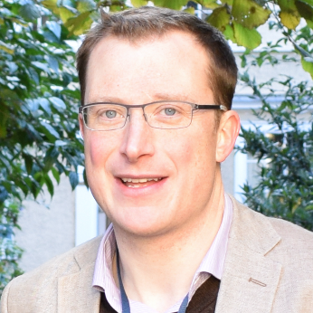 | Dr. Benjamin Fairfax  Titles: Consultant in Medical Oncology, Group Leader  Location: Weatherall Institute of Molecular Medicine  Department: Radcliffe Department of Medicine  Group: Fairfax: Genomics of Inflammation and Cancer Immunology  Webpage: https://www.imm.ox.ac.uk/people/benjamin-fairfax,  https://www.imm.ox.ac.uk/research/research-groups/genomics-of-inflammation-and-cancer-immunology  E-mail: benjamin.fairfax@oncology.ox.ac.uk  PA: Rita de Podesta <rita.depodesta@oncology.ox.ac.uk

GMS themes:

Research Overview
Project areas:

Specific project proposals:

Please contact directly for further information.

These pages were reviewed/updated: 10/06/2022

Project proposal

Title: [Project title here]
Supervisors: [name and title of relevant individuals]
Wet/dry lab mix (approx): X% wet lab, X% dry lab

Description:
[Write a ~ half-page page description of the project here].

Training Opportunities:
[Write a brief description of the training opportunities the project will provide].

Background reading / references:
Please include references as desired. Suggested format:
- [Surname] [Firstname], [other authors]… (year in bold) . [Title]. [Journal name], [other details]. Available at: [link]

Insert any additional project description(s) on subsequent pages if applicable. Please use the same template and use separate pages for each project.

