PI profile

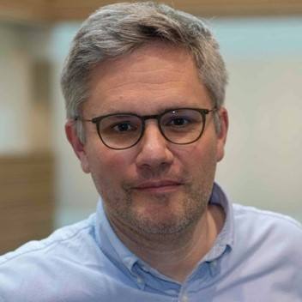 | Professor Christophe Fraser  Titles: Professor of Pathogen Dynamics, Senior Group Leader in the Big Data Institute; Associate Group Leader in the Wellcome Centre for Human Genetics; Associate Faculty Wellcome Trust Sanger Institute; Independent Advisor to NHS Test and Trace.  Location: Big Data Institute, Wellcome Centre for Human Genetics  Department: Nuffield Department of Medicine  Group: Pathogen Dynamics  Webpages: https://www.bdi.ox.ac.uk/Team/christophe-fraser  http://www.coronavirus-fraser-group.org/  https://www.beehive.ox.ac.uk/  https://www.pangea-hiv.org/  http://www.ampheus.org/  Email: christophe.fraser@bdi.ox.ac.uk  Scientific manager: Lucie Abeler-Dorner <lucie.abeler-dorner@bdi.ox.ac.uk>  PA: Carol Mulligan-John <carolena@well.ox.ac.uk>

Research Overview
In the Pathogen Dynamics research group, we study the spread, evolution and control of epidemic pathogens. We are a multidisciplinary team of investigators, including laboratory science, clinical science, bioinformatics, computing, modelling, statistics, and communications/outreach. Because the best way to understand a system is to disrupt it, our guiding principle is that the best way to understand pathogen dynamics is to work alongside medical and public health teams that implement epidemic interventions.

Epidemic modelling and interventions:
Most of the group works on HIV in sub-Saharan Africa. We are involved in major consortia (PANGEA: https://www.pangea-hiv.org/ ). We have developed agent based simulations, and also simple mathematical models. We have supported universal treatment as prevention programmes, and we now support interventions based on outcomes of phylogenetic and social science studies that suggest new approaches to provide care and prevent infections, and we advise on the deployment of novel long-acting pharmaceutical agents. We work with international agencies (UNAIDS, Global Fund) and local investigators and country agencies. We seek to advance the state of the art in evidence synthesis based on agent-based simulations that bring in broad types of data sources: epidemiologic, clinical, phylogenetic, and ethnographic.

Pathogen genetics:
Together with Dr David Bonsall and core staff of the Wellcome Centre for Human Genetics and investigators at the Peter Medawar Building, we have been developing new sequencing methods that have both diagnostic applications and generate rich and granular insights into epidemic dynamics. RNA sequencing that minimises PCR provides quantitative evidence of the abundance of different pathogens, of their resistance to treatment, and of their epidemic history. The practical challenges are manifold, but the aim is clear: we proceed in steps towards a method that is cheap, fast, sensitive, with full length genomes of all the pathogens in the sample, free of contamination, and integrated with robust automated computational pipelines. Progress has been rapid, and there are many applications and opportunities. See (http://www.ampheus.org/)

COVID-19:
Our group has mobilised as part of Oxford’s very broad response to the COVID-19 epidemic. We originated the idea that a contact tracing app could make a big impact on controlling COVID, due to contact tracing being a race against time. We support the NHS Test and Trace programme as independent advisors. See http://www.coronavirus-fraser-group.org/ Alongside this, we have developed models, simulations, and participate in the national sequencing programme (COG-UK). Together with Dr Tanya Golubchik and Dr Katrina Lythgoe, we have investigated the within and between host diversity and evolution of COVID.

Project areas: Epidemiology. Modelling. Simulation. Machine learning. Sequencing methods. Bioinformatics. Software development. Statistics. Public health.
Specific project proposals:

Please contact directly for further information.

These pages were reviewed/updated: [insert date]

Insert any additional project description(s) on subsequent pages if applicable. Please use the same template and use separate pages for each project.

