PI profile

Cath Green
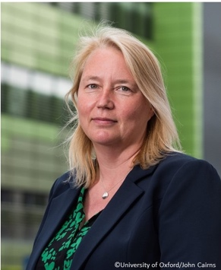 | Dr. Catherine Green  Titles: Associate Professor  Location: Wellcome Centre for Human Genetics  Department: Nuffield Department of Medicine  Group: Chromosome Dynamics  Webpage: Green group — Wellcome Centre for Human Genetics (ox.ac.uk)  Email: catherine.green@well.ox.ac.uk

GMS themes:
- Genomic and –omic technologies
- Genome biology (genomes and genetic variation)
- From genes to clinic (target discovery, structural biology, medicinal chemistry)

Research Overview
I run two teams at the University: Chromosome Dynamics at the Wellcome Centre for Human Genetics and Clinical BioManufacturing for the Nuffield Department of Medicine. Our research interests are, respectively: Genome Stability and DNA mutagenesis, and GMP manufacturing of novel biologics medicines for early phase clinical trials
Project areas: DNA replication, DNA repair, mutagenesis, Chromosome Biology, Cytogenetics, GMP manufacturing

No specific projects will be offered this year, but I am always happy to discuss bespoke options.

Please contact directly for further information.

These pages were reviewed/updated: 27 July 2021

