PI profile

## Simon Leedham

|  |  |
| --- | --- |
|  | **Professor Simon Leedham**  **Titles**: Professor of Molecular and Population Genetics  **Location**: Wellcome Centre for Human Genetics  **Department**: Nuffield Department of Medicine  **Group**: Intestinal Stem Cell Biology  **Webpage**: [url]  **Email**: Simonl@well.ox.ac.uk |

### GMS themes:

[Please retain any that describe your research, deleting others:]

* Genomic and –omic technologies
* Functional genomics
* Genomics of disease
* Application of genomics in the clinic (diagnostics and therapeutics)

### Research Overview

We are interested in the morphogenic control of intestinal stem cell fate in homeostasis, regeneration and cancer. Work ranges from cell fate disruption in the pathogenesis of inflammatory and neoplastic disease, to assessment of individual signalling pathways including preclinical drug testing, as well as cancer heterogeneity and evolution.

Add other section headings as appropriate if desired – Heading 3 style.]

Project areas: Intestinal stem cells, morphogen signalling, preclinical drug testing, cancer heterogeneity

### Specific project proposals:

Projects can be tailored according to student interests

Please contact directly for further information.

*These pages were reviewed/updated:* ***[5/7/21]***

Project proposal

**Title**: Stem cells and adaptive molecular phenotype in colorectal cancer (STAMP-CRC)

Supervisors: Professor Simon Leedham

Wet/dry lab mix (approx): can be wet or dry lab work, or mixture depending on student preference

Description: Tumour heterogeneity plays a key role in cancer adaption and resistance to therapies, but understanding genetic heterogeneity alone cannot paint a complete picture. The forces of natural (and therapeutic) selection act upon phenotypic characteristics, and phenotype is a function of both the genotype and the microenvironment. The capacity to measure and understand relevant cancer cell phenotypic variation is key to monitoring neoplasia evolutionary trajectory. We believe that cancer stem cell molecular phenotype is an informative readout of dynamic evolutionary change within a tumour and is an important, and currently unmeasured metric that can improve prediction of tumour response to treatments, biologically inform existing therapy scheduling and drive the development of cancer cell adaption drug targets. Here we will assess demonstrable cross-species stem cell phenotypic heterogeneity in intestinal tumours, investigate the driving co-evolutionary interaction between the mutant epithelium and surrounding stromal/immune cell compartments, and assess the spatio-temporal impact of therapeutic selective pressures.

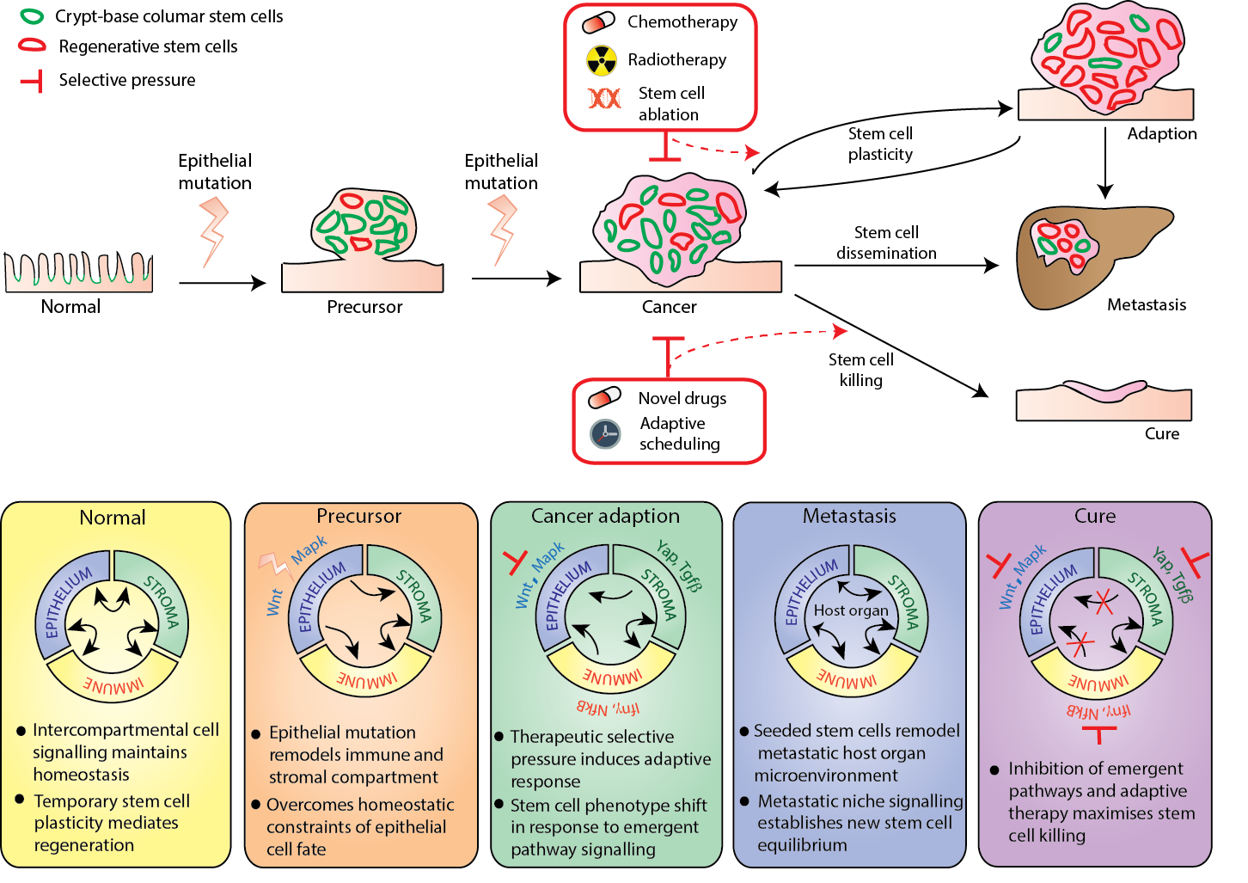

### Training Opportunities:

This would suit a student from any of the eligible pathways with an interest in understanding cancer heterogeneity and tracking tumour evolution and adaption. The project will involve mouse modelling and preclinical drug testing but requires no previous experience. Wet and dry lab training opportunities exist and can be discussed to tailor needs for students

### Background reading / references: