PI profile

Ira Milosevic
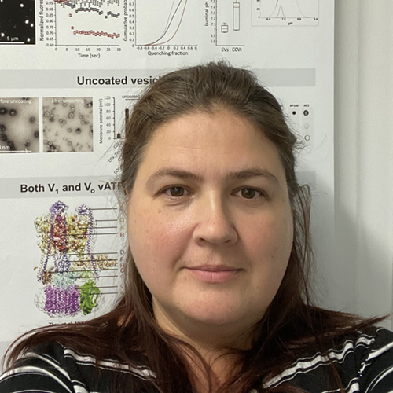 | Dr. Ira Milosevic  Titles: Group Head / PI  Location: Wellcome Centre for Human Genetics  Department: Nuffield Department of Medicine  Group: Milosevic / Neuronal Physiology and Pathology  Webpage: https://www.well.ox.ac.uk/research/research-groups/milosevic-group  https://www.dpag.ox.ac.uk/opdc/team/ira-milosevic?ref=image  Email: imilose@well.ox.ac.uk

GMS themes:
- Genomic and –omic technologies
- Functional genomics
- Genomics of disease

Research Overview
Our group (relocated to Oxford in spring 2021) focuses on comprehending neuronal functions at the molecular level, with the purpose of using this knowledge to address the mechanisms of neurodegenerative diseases, as well as to explore whether certain brain functions (e.g., memory, motor coordination, hearing) can be improved. The emphasis of our research is on the mechanisms underlying exocytosis and endocytosis, and the consequences of their dysfunction, such as impaired synaptic physiology and neurodegeneration. We now aim to ‘translate’ the obtained knowledge to understand the processes that happen at the onset of certain neurodegenerative diseases and to improve their diagnostics by identifying early disease markers. Notably, we also study regulation of organelle acidification and synaptic vesicle ‘maturation’ with a focus on protein-protein interactions underlying these processes.
We employ multi-disciplinary approaches that include behavioral studies, cell biology, electrophysiology, imaging and –omics approaches (transcriptomics, proteomics, metabolomics), and capitalize on a large collection of human cell lines and mouse models with defective SV recycling and/or acidification. Specifically, we are working on the molecular mechanisms underlying exocytosis (e.g., Nat Commun 2020; PNAS USA 2020), endocytosis (e.g., J Cell Biol 2018; Neuron 2018; EMBO J 2019; Nature 2019) and vesicle acidification (eLife 2018). Notably, in the past four years we have discovered two new ways of v-ATPase regulation: by (1) clathrin coat (eLife 2018) and (2) rabconnectin-3 (unnder review). We are also addressing the relevance of defective endocytosis and synaptic vesicle recycling to Parkinson’s disease (PD) and ataxias, e.g. by linking endophilin-A (key endocytic protein) to PD, protein homeostasis and autophagy - Cell Reports 2016, and α-synuclein (key exocytic protein) in endosomal trafficking – PNAS USA 2016. In the context of impaired cell physiology that leads to neurodegeneration, we are exploring the links between defective endocytosis and mitochondria (in collaboration with Raimundo’s lab: Autophagy 2018; eLife 2018; Nature 2019), and the links between protein quality control and aging (in collaboration with Krisko’s lab: Aging Cell 2017; Aging 2018; Nat Commun 2021). In sum, we do our utmost to advance the understanding of neuronal and synaptic physiology with a goal of exploring the extent of brain plasticity in health and disease.
Project areas:
Neuronal cell biology, neurodegeneration, neurotransmission, exocytosis, endocytosis, neurodenerative diseases, Parkinson’s disease, ataxias, diabetes, experimental medicine, live cell imaging

Specific project proposals:
- Characterisation of amisyn, a negative regulator of exocytosis

Please contact directly for further information: Ira Milosevic, imilose@well.ox.ac.uk; Phone: 87622

These pages were reviewed/updated: 30.07.2021

Project proposal
Title: Amisyn at the crossing of modulated neurotransmission and brain pathologies
Supervisor: Ira Milosevic
Wet/dry lab mix (approx): 75% wet lab, 25% dry lab

Description:
The human brain is astonishing: it is the source of our thoughts, actions, memories, perceptions and emotions. It confers on us the abilities that make us human, while simultaneously making each of us unique. Through deepened knowledge and understanding of how human brain works, we will comprehend ourselves better and treat brain diseases more incisively. Over recent years, neuroscience has advanced to the level that we can envision spanning molecules, cells and neuronal circuits in action. In particular, there is an emerging view that subtle aspects of presynaptic dysfunction are implicated in an increasing number of brain disorders.
We are particularly interested in exocytosis, a process of vital importance for neuronal cells that is controlled by a set of both positive and negative regulators. While promotors of exocytosis are well studied, negative regulators are poorly understood. We discovered that a small SNARE protein amisyn (STXBP6) acts as a vertebrate-specific competitor of synaptobrevin-2, a key player in exocytosis. Amisyn contains an N-terminal pleckstrin homology domain that mediates its transient association with the plasma membrane by binding to phospholipid PI(4,5)P₂. Both the pleckstrin homology and SNARE domains are needed to inhibit exocytosis. Of note, amisyn is poorly studied despite several studies have emphasized its importance for exocytosis and reported the occurrence of amisyn mutations in autism-spectrum disorders and diabetes.
This project aims to analyse transcriptome and proteome of transgenic mouse model without amisyn already generated for these studies (the model is not yet unpublished). The candidate will then use transgenic mice tissue, as well as human and rodent cell lines, to verify own findings. If time allows (or if candidate prefers), the studies will extend to amisyn patient mutants, and how lack or impaired function of amisyn modulates exocytosis.

Training Opportunities:
Brain dissection. Transcriptome and proteome analyses of amisyn mutant tissue. Western blotting. Culturing human and/or rodent clonal cells. Immunocytochemistry. Live cell imaging using custom-made fast spinning-disk confocal microscope.

Background reading / references:
Kondratiuk I, Jakhanwal S, Jin J, Narayanan U, Kroppen B, Krisko A, Meinecke M, Asheri U, Jahn R, D. Fasshauer, Milosevic I@ (2020) PI(4,5)P₂-dependent regulation of exocytosis by amisyn, a vertebrate-specific competitor of synaptobrevin 2. PNAS USA, 117(24):13468-79

