PI profile

Simon Myers
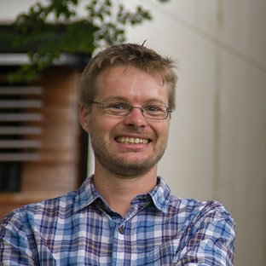 | Professor Simon Myers  Title: Professor of Mathematical Genomics  Location: Henry Wellcome Building of Genomic Medicine  Department: Statistics, Wellcome Centre for Human Genetics  Group: Statistical and Population Genetics  Webpage: https://www.well.ox.ac.uk/people/simon-myers  Email: myers@stats.ox.ac.uk

GMS themes:

Research Overview
Our group works on analytical and experimental approaches to understand genetic variability and its impacts, in health and disease.

One focus is studying meiosis and recombination, a fundamental and key biological process in most species. Recombination is essential for fertility in humans, and with mutation it generates all genetic variation that exists. Errors in recombination cause genomic rearrangements, resulting in many human diseases. One research focus of our group is studying this basic process, and specifically factors influencing recombination event positioning along the genome. This has led on to findings connecting the biological recombination machinery, evolution, fertility, speciation and disease, using a combination of analytical, statistical and experimental approaches. Our work identified the fast-evolving protein PRDM9 as the zinc-finger protein positioning mammalian recombination hotspots (Myers et al., Science, 2010, recently included within the top 21 achievements of WHG researchers, across the 21 years of the centre's existence). We showed that recombination hotspots vary across human populations (Hinch, Nature, 2011). Our recent work studies an example of ongoing speciation in mammals (Davies, Nature, 2016). We showed that humanization of PRDM9’s zinc-finger array in mice rescues fertility in mouse hybrids, reversing speciation. In turn, it gave key insights into the mysterious process of homologous chromosome pairing, which allows proper inheritance of genetic material from parents to children, showing this to depend on sequence matches only at a tiny fraction of the genome.

A second focus of the group is developing statistical approaches to understand admixture and population structure. This work was again chosen among the top 21 achievements of WHG researchers. Population structure is the major potential confounder in disease association studies, and its understanding can also provide direct historical insights. We co-developed (Lawson,
PLoS Genetics, 2012) a method fineSTRUCTURE that has revealed that genetic differences exist at very fine geographic scales within the UK (Leslie, Nature, 2015). We also published work (Hellenthal,
Science, 2014) characterizing, for the first time, the complex ways in which many different mixing events – relating to e.g. the Mongol expansion, and Slavic migrations - have impacted the DNA of human populations worldwide. Ongoing projects are studying UK Biobank data, and work on building the genealogical history of every position in the genome.

Project areas: population genetics, stochastic models, mapping disease genes, methods for fine-mapping association signals.

Specific project proposals:
- ‘Re‐engineering the DNA binding characteristics of a speciation gene’
Please contact directly for further information.

These pages were reviewed/updated: 10/06/2022

Project proposal

Title: [Project title here]
Supervisors: [name and title of relevant individuals]
Wet/dry lab mix (approx): X% wet lab, X% dry lab

Description:
[Write a ~ half-page page description of the project here].

Training Opportunities:
[Write a brief description of the training opportunities the project will provide].

Background reading / references:
Please include references as desired. Suggested format:
- [Surname] [Firstname], [other authors]… (year in bold) . [Title]. [Journal name], [other details]. Available at: [link]

Insert any additional project description(s) on subsequent pages if applicable. Please use the same template and use separate pages for each project.

