PI profile

Benjamin Schuster-Böckler
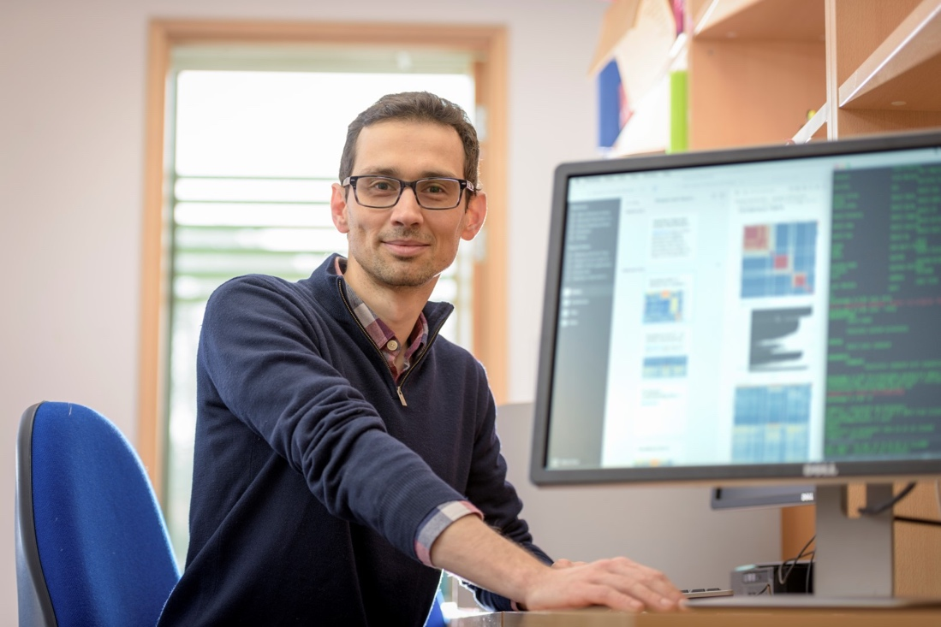 | Dr. Benjamin Schuster-Böckler  Titles: Group Leader, Assistant Member of Ludwig Cancer Research  Location: Big Data Institute  Department: Ludwig Institute for Cancer Research  Group: Computational genomics  Webpage: https://www.ludwig.ox.ac.uk/research/schuster-boeckler-group-page  Email: benjamin.schuster-boeckler@ludwig.ox.ac.uk

GMS themes:
- Genome biology (genomes and genetic variation)
- Genomics of disease
- Genomic analysis (bioinformatics and statistical genetics)
- Application of genomics in the clinic (diagnostics and therapeutics)

Research Overview
My research group uses genomic data to study the processes that lead to cancer. We are interested in the fundamental questions of “how, why and where do mutations occur in the genome”. Lately, we have also begun to try to use our understanding of genetic and epigenetic changes that happen during tumour formation to develop better diagnostic tests for cancer.
My group is primarily funded through Ludwig Cancer Research and located at the Big Data Institute. We collaborate closely with many experimental and clinical teams in Oxford who provide us with data. In return we provide them not just with answers to their questions, but also with new hypotheses they could test experimentally, based on preliminary data we extract computationally.
One area we are particularly interested in are cancers of the upper gastrointestinal tract. Oesophageal and stomach adenocarcinomas share a lot of molecular similarities. For unknown reasons, however, oesophageal cancers are becoming more common in the western world, while stomach cancers incidence is going down. One focus area of our research is therefore to try to understand which mechanisms underly the accumulation of mutations in oesophageal cancer.
We have recently been involved in the development of a new method to measure epigenetic alterations in DNA. This technique, called TAPS (Tet-Assisted Pyridine-borane Sequencing), is cheaper, more accurate and better suited for very small samples compared to older methods. Our collaborators have generated plenty of data from different cancers, healthy tissue and from cell-free DNA. Leveraging our knowledge of cancer genetics and epigenetics, we are now working on algorithms to detect cancer-specific features that are predictive of treatment success or able to distinguish cancer patients from healthy controls.
Project areas: cancer epigenetics, causes of mutagenesis, tumour evolution, cancer early detection, predicting response to immunotherapy

Specific project proposals:
- ‘Early detection of liver cancer using cell-free DNA and other measurements’
- ‘What drives trophoblastic tumours?’
Please contact directly for further information.

These pages were reviewed/updated: 28/09/2022

Project proposal

Title: Early detection of liver cancer using cell-free DNA and other measurements
Supervisors: Benjamin Schuster-Böckler, Ellie Barnes
Wet/dry lab mix (approx): 100% dry lab

Description:
Liver cancer is common amongst patients who have been diagnosed with liver cirrhosis, but so far it is not possible to reliably predict which cirrhosis patient will develop cancer. This makes it costly and difficult to screen the large at-risk population.
My group is participating in a large trial funded by CRUK to address this critical clinical need. There are two cohorts, a retrospective and a prospective cohort. For both groups, a number of measurements are collected at different time-points: ultrasound imaging, protein biomarkers, metabolomics data from the blood, and cell-free DNA methylation.
If you choose this project for a rotation, you will first work on the cell-free DNA data. We will try to determine liver-cancer specific features in the methylation patterns and the read-density from cancer and control patients. We will also search for known liver-cancer mutations in the cfDNA.
If you continue on to a DPhil, the aim will be to fully develop the cell-free DNA analysis into an assay. This will involve developing a robust classifier, quantifying the accuracy and variability of the classifier, estimating the positive predictive value, and determining the minimal set of genomic regions that are informative, in order to reduce the sequencing cost. The next step will be to integrate the predictions from cell-free DNA with the information from the other measurements, to determine whether the accuracy of the test can be further improved by incorporating other data.

Training Opportunities:
This project would suit a statistically minded person who would like to work on a real-world problem using genomic data. You would learn basic computational genomics techniques and get expose to biomarker discovery and evaluation in the setting of a large collaborative project.

Background reading / references:
- Liu, Y. et al. Bisulfite-free direct detection of 5-methylcytosine and 5-hydroxymethylcytosine at base resolution. Nat Biotech 37, 424-429 (2019).
- https://www.oxcode.ox.ac.uk/research-showcase/liver-cancer
- Siejka-Zielińska, P. et al. Cell-free DNA TAPS provides multimodal information for early cancer detection. Sci Adv 7, eabh0534 (2021).

Project proposal
Title: The epigenetic landscape of the human body
Supervisors: Benjamin Schuster-Böckler, Chunxiao Song
Wet/dry lab mix (approx): 100% dry lab

Description:
DNA methylation is an important determinator of cell fate by “switching off” certain genes that are not needed in more differentiated cells. Methylation - and its further modified form of “hydroxymethylation” - also impact on the activity of retroviruses, transposable elements and non-coding RNA, they are involved in DNA repair processes, and might affect a range of other biological processes, some of which are not yet fully understood.
The Song lab developed methods to measure methylation and hydroxymethylation using much milder chemistry compared to existing approaches. They now created an atlas of cell- or tissue-type specific methylation and hydroxymethylation from dozens of different sites in the body, as well as various cancer types. This unique resource of nearly 200 whole-genome epigenetic maps can be used to address a whole range of biological questions regarding the function and impact of DNA modifications.
For the rotation phase of the project, you would investigate basic covariates in the data, such as the relationship between epigenetic patterns within the same tissue depending on age or gender of the donor, and whether there are tissue independent features that consistently change with age or gender.
For the continuation into a DPhil, you could e.g. investigate tissue-dependent methylation and hydroxymethylation patterns inside and outside of regulatory elements, to deepen our understanding of the biological role of these marks. We would also aim to use these maps to explore the relationship between methylation and chromatin structure and develop ways to apply this knowledge for early disease detection, for example using cell-free DNA or other biopsies.

Training Opportunities:
This project would suit anyone with an interest in genome biology who is keen to perform statistical analysis on large data. You would learn basic computational genomics techniques and gain a lot of knowledge on the role and function of epigenetic regulation in health and disease.
Background Reading/References
- Greenberg, M. V. C. & Bourc’his, D. The diverse roles of DNA methylation in mammalian development and disease. Nat Rev Mol Cell Biol 20, 590-607 (2019).
- Liu, Y. et al. Bisulfite-free direct detection of 5-methylcytosine and 5-hydroxymethylcytosine at base resolution. Nat Biotech 37, 424-429 (2019).
- Liu, Y. et al. Subtraction-free and bisulfite-free specific sequencing of 5-methylcytosine and its oxidized derivatives at base resolution. Nat Commun 12, 618 (2021).

Project proposal
Title: What drives trophoblastic tumours?
Supervisors: Benjamin Schuster-Böckler, Máire Ní Leathlobhair, Yang Shi
Wet/dry lab mix (approx): 50% dry lab, 50% wet lab

Description:
Gestational trophoblastic disease (GTD) describes a group of rare pregnancy-related tumours arising from the abnormal development of trophoblast, the cells that form the placenta. Globally, 18,000 women per year develop GTD and disease has a distinct pattern of geographical distribution, with higher incidence in the developing world. These tumours are unconventional biological entities - they are the only example of a human tumour that develops from the cells of another individual, the fetus.
To date there has been relatively little work examining the potential role of genetic and epigenetic changes in the pathogenesis of gestational tumours. Limited sequencing data suggests that tumours have an extremely low mutation rate and harbour very few recurrent genetic events similar to many paediatric malignancies. Moreover, recent data suggests that that the malignant phenotype is more likely to be based on epigenetic rather than genetic changes. We recently managed to get access to a large number of GTD samples which are ready to be processed, providing a unique resource to study the biology of this disease and the mechanisms that underpin early development.
The focus of the rotation project would be to characterize DNA patterns across a ‘discovery cohort’ of GTD tumours, as well as normal placenta at different stages of development, and to apply clustering approaches to identify distinct disease subgroups. You would then further characterize and validate the most predictive genomic regions in a large cohort of GTD tumours.
The next stage of this project, if you continue on to a PhD, would be to work with laser-capture microscopy to excise and sequence clusters of trophoblast cell subtypes from different GTDs. By applying RNA and DNA methylation sequencing to samples, the aim is to identify the specific alterations that define their proliferative phenotype, to determine whether these differ between trophoblast clones, and to compare this to similar data from normal placental samples.
The placenta plays a crucial role as the interface between mother and child during pregnancy and placenta-related complications of pregnancy, including GTD, are a major challenge for maternal health. This research has the potential to inform our understanding of the early stages of placental development and, in particular, the processes controlling proliferation and how these can go awry.

Training Opportunities:
This project involves both experimental and computational work. You would have a chance to delve into computational genomics techniques as well as learning to perform DNA methylation experiments using the novel TAPS assay, single-cell RNA-seq and low-volume DNA-seq experiments.
Background Reading/References
- Savage, P. et al. A case of intraplacental gestational choriocarcinoma; characterised by the methylation pattern of the early placenta and an absence of driver mutations. BMC Cancer 19, 744 (2019).
- Seckl, M. J. et al., Gestational trophoblastic disease. The Lancet 376, 9742 (2010).
- Coorens, T.H.H. et al. Inherent mosaicism and extensive mutation of human placentas. Nature 592, 80–85 (2021).

