PI profile

Adrian Smith
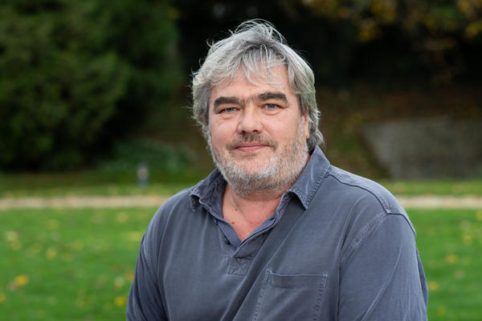 | Dr Adrian Smith  Titles: Associate Professor of Infectious Disease  Location: Peter Medawar Building for Pathogen Research  Department: Zoology  Group: Smith: Comparative Infection and Immunity Group  Webpage: https://www.zoo.ox.ac.uk/people/dr-adrian-smith  Email: adrian.smith@zoo.ox.ac.uk

GMS themes:
[Please retain any that describe your research, deleting others:]
- Genome biology (genomes and genetic variation)
- Genomics of disease
- Genomic analysis (bioinformatics and statistical genetics)

Research Overview
The group employs a comparative biology approach to investigate the evolution and function of the immune system and interactions with pathogens. We work with an extremely wide range of host species including humans, rodents, badgers, bats, chickens, penguins, other vertebrates and corals considering immune processes and functional immunogenetics. Some projects are very focussed on a single host species whilst others consider processes more broadly across wider phylogenetic groups. We have expertise working with viral, bacterial and parasitic infections as well as the enteric microbiome. Although much of the work is with modern samples we also work with archaeological samples and ancient DNA (aDNA). Our current projects in the aDNA area include the molecular archaeoparasitology of helminth parasites that infect humans and the impact of past events on farm animal immune systems.

Approaches: Molecular and cellular biology, bioinformatics, functional immunology, pathogen genetics, modern and ancient DNA

Project areas: [please include several keywords or phrases reflecting your research area and proposed projects.]

Specific project proposals:
I am happy to discuss potential projects in any area that fits with the group. However, to begin with we have two potential projects both co-supervised by Greger Larson (Archaeology) that relate immunity and infectious disease to past populations.
- ‘Molecular archaeoparasitology approaches to interrogate past populations’ (Supervisors: Adrian Smith, Greger Larson and Patrik Flammer).
- ‘Using ancient DNA to understand the impact of humans on the immune system of domesticated animals’ (Supervisors: Greger Larson, Adrian Smith and Laurent Frantz).

These pages were reviewed/updated: 3rd October 2021

Project proposal

Title: Molecular archaeoparasitology approaches to interrogate past populations

Supervisors: Professor Adrian Smith, Professor Greger Larson and Dr Patrik Flammer
Wet/dry lab mix (approx): mixed

Description:
Humans can be infected by a wide range of intestinal parasites including helminths and protozoa and many of these parasites are important in large parts of the world, particularly low and middle income countries. Many of these parasites were much more widespread in past populations. Indeed, our recent work demonstrates that a range of helminths were highly prevalent in Medieval Europe (Flammer et al., 2020). As well as being important for human health the diverse life histories of these parasites offer much more information on other aspects of life including sanitation, hygiene, diet and culinary practices (Flammer et al., 2018). The transmission stages of enteric parasites are incredibly robust preserving ancient DNA. Using a combination of parasitological and aDNA approaches we can interrogate many aspects of life in past populations and can also impact on the approaches used in modern control programmes.
The project: Molecular archeaoparasitology is an emerging area of research that combines both parasitological and aDNA methods to interrogate infection biology and life of past populations. This project will continue to develop these powerful approaches exploring how pathogen genetics cab be used to identify links between human populations. We anticipate that the project will extend the aDNA approaches including developing baiting based aDNA technologies as well as broadening the array of target parasites to include protozoa as well as helminths.

Training Opportunities:
The DPhil will support training in a wide range of parasitological and molecular approaches, in particular those employing ancient DNA. The project will also involve extensive bioinformatics training and will provide an appreciation of how we can use aDNA approaches to understand the past and influence the present.

Background reading / references:
- Flammer PG, Dellicour S, Preston SG, Rieger D, Warren S, Tan CKW, Nicholson R, Přichystalová R, Bleicher N, Wahl J, Faria NR, Pybus OG, Pollard M and Smith AL. (2018) Molecular archaeoparasitology identifies cultural changes in the Medieval Hanseatic trading centre of Lübeck. Proc. R. Soc. B.285:20180991. http://doi.org/10.1098/rspb.2018.0991
- Flammer PG, Ryan H, Preston SG, Warren S, Přichystalová R, Rainer Weiss, Valerie Palmowski, Sonja Boschert, Katarina Fellgiebel, Isabelle Jasch-Boley, Madita-Sophie Kairies, Ernst Rümmele, Dirk Rieger, Beate Schmid, Ben Reeves, Rebecca Nicholson, Louise Loe, Christopher Guy, Tony Waldron, Jiří Macháček, Joachim Wahl, Mark Pollard, Greger Larson and Adrian L. Smith (2020) Epidemiological insights from a large-scale investigation of intestinal helminths in Medieval Europe. PLOS Neglected Tropical Diseases 14(8): e0008600. https://doi.org/10.1371/journal.pntd.0008600

