PI profile

## [Irina] [Udalova]

|  |  |
| --- | --- |
|  | Professor Irina Udalova **Titles**: Professor of Molecular immunology. Head of Laboratory of Genomics of Inflammation, Group Leader / PI, Member of congregation  **Location**: Kennedy Institute of Rheumatology  **Department**: NDORMS  **Group**: Laboratory of Genomics of Inflammation  **Webpage**: <https://www.kennedy.ox.ac.uk/team/irina-udalova>  **Email**: [Irina.udalova@kennedy.ox.ac.uk](mailto:Irina.udalova@kennedy.ox.ac.uk) |

### GMS themes:

* Genomic and –omic technologies
* Functional genomics
* Genome biology (genomes and genetic variation)
* Genomics of disease
* Genomic analysis (bioinformatics and statistical genetics)
* From genes to clinic (target discovery, structural biology, medicinal chemistry)

### Research Overview

Inflammation is a normal and self-limiting physiological response to infection and injury but if sustained can lead to extensive tissue damage and disability, manifested in a variety of chronic inflammatory disorders, ranging from autoimmune diseases to atherosclerosis, Alzheimer’s and cancer. The main research interest of the group is understanding how the inflammatory response is controlled on the molecular level (*Nature Immunology 2011, Science Immunology 2020*). It is driven by changes in the tissue microenvironment, the activation of tissue-resident cells, such as macrophages, and the infiltration of effector myeloid effector cells, such as monocytes, neutrophils. By combining the state-of-the art functional genomic approaches, including single cell genomics, CRISPR screen, proteomics and imaging, with classical molecular and cellular immunology my laboratory is unravelling the transcriptional circuitry that control myeloid cell phenotypes in development and inflammation (*Nature Immunology 2021*). Our aim is to discover regulatory factors controlling cell development and activation under specific microenvironment, that will lead to new therapeutic strategies tailored to specific conditions (*Nature Medicine 2015*).

Our recent pioneering work on neutrophil development and function has established the first transcriptional blueprint of neutrophil responses in acute inflammation (*Nature Immunology 2021*). It has opened possibilities for stage-specific therapeutic modulation of neutrophil function in disease. Projects will be tailored to personal interests and involve both a wet lab and a data analysis/bioinformatics component.

Project areas: myeloid cell development; neutrophil genomics; state-of-the-art functional genomic approaches; high throughput imaging screens combined with single cell genomics; network analysis; model building.

### Specific project proposals:

* Transcriptional blueprint of neutrophil development during homeostasis and disease

Please contact directly for further information.

*These pages were reviewed/updated:* ***[05/07/2021]***

Project proposal

# **Title**: Transcriptional blueprint of neutrophil development during homeostasis and disease

Supervisors: Professor Irina Udalova, Dr Abhinandan Devaprasad. Prof Julia Knight

Wet/dry lab mix (approx): 30% wet lab, 70% dry lab

### Description:

Neutrophils exert anti-microbial activity through several mechanisms including release of cytotoxic products, reactive oxygen species (ROS), neutrophil extracellular traps (NETs) and pore-forming molecules. The presence of immature neutrophil subsets with abnormal functions are consistently associated with inflammation-driven pathologies, including vasculitis, sepsis and severe Covid19. The molecular control of pathogenic neutrophil responses is largely unknown. We have recently developed a state-of-the-art genomic platform to reveal transcriptional circuits that control neutrophil function and identified novel putative regulators. The identified transcriptional regulators were functionally validated using genetic CRISPR-Cas9 mediated ablation *ex vivo*. We assessed the ability of genetically modified neutrophils to control the production of inflammatory mediators and ROS, form NETs etc and highlighted the regulators that were essential for neutrophil development and/or activation. We are currently developing new mouse models for neutrophil-specific deletion of the identified key regulators.

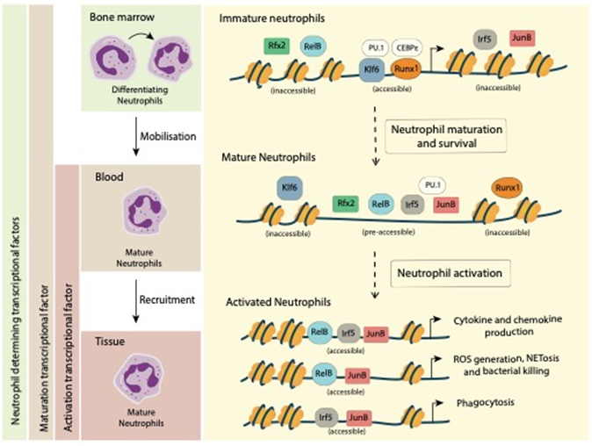

***Figure: Model of transcriptional regulation of neutrophils during inflammation.*** *In the process of differentiation in bone marrow, lineage-determining transcriptional factors, including RUNX1, KLF6, CEBPE, and PU.1, are highly expressed and ensure gene expression programmes that promote proper neutrophil maturation. During the mobilization from the bone marrow into the blood, RFX2, RELB, IRF5 and JUNB become upregulated and transcriptionally accessible to support neutrophil cell survival and establish their effector function repertoire, whereas RUNX1 and KLF6 expression are silenced. Upon inflammation, circulating neutrophils migrate into the inflammatory sites, where they are exposed to inflammation-derived signals and become activated. Neutrophil activation leads to the activation of TFs, including RELB, IRF5 and JUNB, and subsequent TF binding to already accessible binding sites, thereby resulting in diverse TFs genomic occupancy and distinct transcriptional outputs (see Nature Immunology 2021).*

The goal of this project is to generate the regulatory blueprint of neutrophil states during development and in a signal-driven microenvironment based on the already identified and functionally validated novel neutrophil regulators. This will be done by using a combination of advanced genomic, epigenomic, immunological techniques, including cutting edge single cell technologies. The multi-scale computational analysis and modelling will be used for quantitative analysis and interpretation of resulting experimental data. The work will also inform understanding of the mechanistic basis of genetic drivers of individual variation in neutrophil gene function arising from expression quantitative trait mapping, for example allele-specific differences involving key transcriptional regulators. There is also the opportunity to extend the approach to work with primary neutrophils from patients with severe infection through established local studies to understand context-specific effects.

The outcome of this study is expected to progress fundamental biology of neutrophils, increase our understanding of neutrophil activated subsets in disease and aid the development of new targets for therapeutic interventions in inflammatory disorders.

### Training Opportunities:

Training will be provided in techniques in a wide range of functional genomics approaches (RNA-Seq, ATAC-Seq, ChIP-Seq), immunological (cell isolation, tissue culture, FACS), and imaging (immunofluorescence on tissue sections) approaches, as well as cutting edge single cell platforms (10x, CyTOF) and computational pipelines. Recently developed novel *in vivo* models of inflammatory diseases will be extensively used and new models will be generated. Students will attend weekly seminars within the department and those relevant in the wider University and receive training in scientific writing and communication through oral presentations to the scientific community at international conferences. Students will also have the opportunity to work closely with members of the Oxford Covid19 immunology network, as well as Novonordisk Immunometabolism consortium (Oxford/Karolinska Institute/University of Copenhagen).

### Background reading / references:

* Ai Z, **Udalova IA**. Transcriptional Regulation of Neutrophil Differentiation and Function During Inflammation. ***Journal of Leukocyte Biology* 2020** Mar;107(3):419-430.
* Wang L, Luqmani R, **Udalova IA**. The role of neutrophils in rheumatic disease-associated vascular inflammation. ***Nature Reviews Rheumatology***. **2022** Mar;18(3):158-170.
* Khoyratty T*, Ai Z*, Ballesteros I, Mathie S, Eames HL, Martín-Salamanca S, Wang L, Hemmings A, Willemsen N, von Werz V, Zehrer A, Walzog B, van Grinsven E, Hidalgo A, **Udalova IA**. Distinct transcription factor networks control neutrophil-driven inflammation. ***Nature Immunology***, **2021,** Sep;22(9):1093-1106.
* Kwok A, Allcock A, Ferreira R, Smee M, Cano-Gamez E, Burnham KL, Zurke YX, Oxford acute medicine/ED research, McKechnie S, Monaco C, **Udalova IA**, Hinds CE, Davenport EE, Todd JA and **Knight JC.** Identification of deleterious neutrophil states and altered granulopoiesis in sepsis. medRxiv 2022.03.22.22272723.